Use Case Descriptions
Use Case: UC01 Public User Registration and Incident Reporting
Primary Actor: Public User
Goal: To report an incident and submit a Unified Communication (UC) form to the Public Safety and Security Department (PSSD) for verification and processing.
Description:
1. The public user registers for a public user ID and gains access to the system.
2. The user submits a UC form, providing basic information such as the type of incident, location, date and time, and any relevant remarks, along with a picture.
3. The PSSD HSE Officer verifies and filters the submitted form, and if approved, proceeds to the next step.
4. The PSSD notifies the related department (FMD/ICT, etc.) and SHE Reps at the related department.
5. The SHE Rep uploads a picture and provides additional details after taking action on the reported incident.
6. The PSSD HSE Officer confirms the action taken and notifies the related PSSD HOS.
7. The selected PSSD HOS approves or confirms the action taken.
8. The HOD confirms the action taken, and the process is fully closed.
Preconditions:
♣ The public user has registered for a public user ID and gained access to the system.
♣ The user has submitted a UC form with the required information and picture.
Triggers:
♣ The public user submits a UC form.
Postconditions:
♣ The PSSD has received and processed the UC form.
♣ The related department and SHE Reps have been notified.
♣ The incident has been addressed, and the process is fully closed.
Extensions:
♣ If the PSSD HSE Officer rejects the submitted form, the user will be notified, and the process will start again from the beginning.
♣ If the PSSD HSE Officer requires additional information or clarification, the user will be notified, and the process will start again from the beginning.

Use Case: UC02 Public User Notification
Primary Actor: Public User
Goal: To notify the Public Safety and Security Department (PSSD) of an incident and provide basic information for notification purposes.
Description:
1. The public user registers for a public user ID and gains access to the system.
2. The user submits a UA form, providing basic information such as the type of incident, location, date and time, and any relevant remarks, along with a picture.
3. The PSSD HSE Officer verifies and filters the submitted form, and if approved, proceeds to the next step.
4. The PSSD HSE Officer takes follow-up action and notifies/channels the related HOS.
5. The selected PSSD HOS verifies and confirms the action taken.
6. The HOD approves the action taken, and the process is closed.
7. If the public user requests a review or reopen, they can do so up to a maximum of three times after the form is closed.
8. If the request for review or reopen is approved, the process starts again from step 3.
Preconditions:
♣ The public user has registered for a public user ID and gained access to the system.
♣ The user has submitted a UA form with the required information and picture.
Triggers:
♣ The public user submits a UA form.
Postconditions:
♣ The PSSD has received and processed the UA form.
♣ The related HOS has been notified.
♣ The incident has been addressed, and the process is closed.
Extensions:
♣ If the public user requests a review or reopen, the process will start again from step 3.
♣ If the public user requests a review or reopen more than three times, the process will be fully closed.

Use Case: UC03 Public Selected User Notification, Verbal Warning, and Stop Work
Primary Actor: Public Selected User
Goal: To notify the Public Safety and Security Department (PSSD) of an incident and provide intermediate information or action taken, such as verbal warning or stop work, for notification purposes.
Description:
1. The public selected user registers for a public user ID and gains access to the system after their access role is updated by PSSD.
2. The user submits a UA form, providing intermediate information or action taken, such as type of incident, verbal warning or stop work, location, date and time, and any relevant remarks, along with a picture.
3. The PSSD HSE Officer verifies and filters the submitted form, and if approved, proceeds to the next step.
4. The PSSD HSE Officer takes follow-up action and notifies/channels the related HOS.
5. The selected PSSD HOS verifies and confirms the action taken.
6. The HOD approves the action taken, and the process is closed.
7. If the public selected user requests a review or reopen, they can do so up to a maximum of three times after the form is closed.
8. If the request for review or reopen is approved, the process starts again from step 3.
Preconditions:
♣ The public selected user has registered for a public user ID and gained access to the system after their access role is updated by PSSD.
♣ The user has submitted a UA form with the required information and picture.
Triggers:
♣ The public selected user submits a UA form.
Postconditions:
♣ The PSSD has received and processed the UA form.
♣ The related HOS has been notified.
♣ The incident has been addressed, and the process is closed.
Extensions:
♣ If the public selected user requests a review or reopen, the process will start again from step 3.
♣ If the public selected user requests a review or reopen more than three times, the process will be fully closed.

Use Case: UC04 PSSD Personnel Action - Revoke Entry Permit
Primary Actor: PSSD Personnel
Goal: To take all necessary actions to revoke an entry permit and submit a Unified Action (UA) form to the Public Safety and Security Department (PSSD) for processing.
Description:
1. The PSSD personnel registers for a public user ID and gains access to the system after their access role is updated by PSSD.
2. The personnel submit a UA form, providing intermediate information or action taken, such as violator details, type of UA, all action, location, date and time, and any relevant remarks, along with a picture.
3. The PSSD HSE Officer takes follow-up action and notifies/channels the related HOS.
4. The selected PSSD HOS verifies and confirms the action taken.
5. The HOD approves the action taken, and the process is closed.
6. If the PSSD personnel requests a review or reopen, they can do so up to a maximum of three times after the form is closed.
7. If the request for review or reopen is approved, the process starts again from step 3.
Preconditions:
♣ The PSSD personnel has registered for a public user ID and gained access to the system after their access role is updated by PSSD.
♣ The personnel have submitted a UA form with the required information and picture.
Triggers:
♣ The PSSD personnel submits a UA form.
Postconditions:
♣ The PSSD has received and processed the UA form.
♣ The related HOS has been notified.
♣ The entry permit has been revoked, and the process is closed.
Extensions:
♣ If the PSSD personnel requests a review or reopen, the process will start again from step 3.
♣ If the PSSD personnel requests a review or reopen more than three times, the process will be fully closed.

Use Case: UC01: User Management
Primary Actor: ICT Admin
Goal: The ICT Admin wants to manage user accounts and profiles in the system to ensure secure and efficient access to the organization's resources.
Description:
The ICT Admin needs to create, update, and delete user accounts and profiles in the system. This includes adding new users, modifying existing user information, and removing inactive or terminated employees. The ICT Admin also needs to assign user roles and permissions to ensure that users have the necessary access to perform their job functions.
Triggers:
- New employee hire
- Employee termination
- Change in job role or responsibilities
- Request from a user to update their profile information
Preconditions:
- The ICT Admin has the necessary permissions and access to the system.
- The system is available and functioning correctly.
Basic Flow:
- The ICT Admin logs in to the system.
- The ICT Admin searches for the user account to be managed (create, update, or delete).
- The ICT Admin selects the desired action (create, update, or delete) and provides the necessary information (e.g., user name, password, role, permissions).
- The system validates the input and performs the requested action.
- The ICT Admin reviews the updated user account or profile information.
- The ICT Admin saves the changes or cancels the action.
Alternative Flows:
- If the ICT Admin tries to create a user account with an existing username, the system will prompt an error message and prevent the creation of the duplicate account.
- If the ICT Admin tries to delete a user account that is still active, the system will prompt a warning message and prevent the deletion.
Postconditions:
- The user account or profile information has been successfully created, updated, or deleted.
- The ICT Admin has been notified of any errors or warnings during the process.
Extensions:
- The ICT Admin can also reset user passwords or unlock locked accounts.
- The ICT Admin can view a list of all user accounts and their corresponding roles and permissions.

Use Case 02: User Roles
Primary Actor: ICT Admin
Goal: To define and manage user roles within the Johor Port Berhad Unsafe Conditions and Unsafe Acts System (UCUX).
Description: The ICT Admin creates and manages user roles within the UCUX system, assigning permissions and access levels to each role. This ensures that users have the necessary access to perform their tasks and responsibilities, while also maintaining the security and integrity of the system.
Triggers:
- The ICT Admin needs to create a new user role
- A user's role needs to be updated or changed
- A user's access level needs to be adjusted
Preconditions:
- The ICT Admin has the necessary permissions and access to manage user roles
- The UCUX system is operational and accessible
Postconditions:
- The user role is created, updated, or changed as requested
- The user's access level is adjusted accordingly
- The UCUX system reflects the updated user role and access level
Main Flow:
- The ICT Admin logs into the UCUX system
- The ICT Admin navigates to the user role management page
- The ICT Admin creates a new user role or updates an existing one
- The ICT Admin assigns permissions and access levels to the user role
- The ICT Admin saves the changes
- The UCUX system reflects the updated user role and access level
Alternative Flows:
- If the ICT Admin encounters an error while creating or updating a user role, they may need to troubleshoot the issue or seek assistance from a higher authority.
- If a user's role needs to be deleted, the ICT Admin may need to ensure that the user's access level is adjusted accordingly and that the user is notified of the change.

Use Case 03: Settings
Primary Actor: ICT Admin
Goal: To configure and manage system settings within the Johor Port Berhad Unsafe Conditions and Unsafe Acts System (UCUX).
Description: The ICT Admin configures and manages system settings within the UCUX system, ensuring that the system operates efficiently and effectively. This includes setting up system parameters, configuring notifications, and managing system logs.
Triggers:
- The ICT Admin needs to configure a new system setting
- A system setting needs to be updated or changed
- A system issue needs to be investigated and resolved
Preconditions:
- The ICT Admin has the necessary permissions and access to manage system settings
- The UCUX system is operational and accessible
Postconditions:
- The system setting is created, updated, or changed as requested
- The UCUX system reflects the updated system setting
- The system issue is investigated and resolved
Main Flow:
- The ICT Admin logs into the UCUX system
- The ICT Admin navigates to the system settings page
- The ICT Admin selects the system setting to be configured or updated
- The ICT Admin makes the necessary changes to the system setting
- The ICT Admin saves the changes
- The UCUX system reflects the updated system setting
Alternative Flows:
- If the ICT Admin encounters an error while configuring or updating a system setting, they may need to troubleshoot the issue or seek assistance from a higher authority.
- If a system issue needs to be investigated and resolved, the ICT Admin may need to review system logs, consult with other stakeholders, and implement a solution to resolve the issue.

Use Case 04: Manage Company
Primary Actor: PSSD Admin
Goal: To manage company information and settings within the Johor Port Berhad Unsafe Conditions and Unsafe Acts System (UCUX).
Description: The PSSD Admin manages company information and settings within the UCUX system, ensuring that the system is configured to meet the company's needs. This includes setting up company details, configuring company-wide settings, and managing company users.
Triggers:
- The PSSD Admin needs to update company information
- A company setting needs to be updated or changed
- A company user needs to be added or removed
Preconditions:
- The PSSD Admin has the necessary permissions and access to manage company settings
- The UCUX system is operational and accessible
Postconditions:
- The company information is updated as requested
- The company setting is updated or changed as requested
- The company user is added or removed as requested
Main Flow:
- The PSSD Admin logs into the UCUX system
- The PSSD Admin navigates to the company management page
- The PSSD Admin selects the company information or setting to be updated
- The PSSD Admin makes the necessary changes to the company information or setting
- The PSSD Admin saves the changes
- The UCUX system reflects the updated company information or setting
Alternative Flows:
- If the PSSD Admin encounters an error while updating company information or settings, they may need to troubleshoot the issue or seek assistance from a higher authority.
- If a company user needs to be added or removed, the PSSD Admin may need to ensure that the user's access level is adjusted accordingly and that the user is notified of the change.
Use Case 05: Manage Department
Primary Actor: PSSD Admin
Goal: To manage department information and settings within the Johor Port Berhad Unsafe Conditions and Unsafe Acts System (UCUX).
Description: The PSSD Admin manages department information and settings within the UCUX system, ensuring that the system is configured to meet the department's needs. This includes setting up department details, configuring department-wide settings, and managing department users.
Triggers:
- The PSSD Admin needs to update department information
- A department setting needs to be updated or changed
- A department user needs to be added or removed
Preconditions:
- The PSSD Admin has the necessary permissions and access to manage department settings
- The UCUX system is operational and accessible
Postconditions:
- The department information is updated as requested
- The department setting is updated or changed as requested
- The department user is added or removed as requested
Main Flow:
- The PSSD Admin logs into the UCUX system
- The PSSD Admin navigates to the department management page
- The PSSD Admin selects the department information or setting to be updated
- The PSSD Admin makes the necessary changes to the department information or setting
- The PSSD Admin saves the changes
- The UCUX system reflects the updated department information or setting
Alternative Flows:
- If the PSSD Admin encounters an error while updating department information or settings, they may need to troubleshoot the issue or seek assistance from a higher authority.
- If a department user needs to be added or removed, the PSSD Admin may need to ensure that the user's access level is adjusted accordingly and that the user is notified of the change.

Use Case 06: Manage Offense
Primary Actor: PSSD Admin
Goal: To manage offense information and settings within the Johor Port Berhad Unsafe Conditions and Unsafe Acts System (UCUX).
Description: The PSSD Admin manages offense information and settings within the UCUX system, ensuring that the system is configured to meet the offense's needs. This includes setting up offense details, configuring offense-wide settings, and managing offense users.
Triggers:
- The PSSD Admin needs to update offense information
- An offense setting needs to be updated or changed
- An offense user needs to be added or removed
Preconditions:
- The PSSD Admin has the necessary permissions and access to manage offense settings
- The UCUX system is operational and accessible
Postconditions:
- The offense information is updated as requested
- The offense setting is updated or changed as requested
- The offense user is added or removed as requested
Main Flow:
- The PSSD Admin logs into the UCUX system
- The PSSD Admin navigates to the offense management page
- The PSSD Admin selects the offense information or setting to be updated
- The PSSD Admin makes the necessary changes to the offense information or setting
- The PSSD Admin saves the changes
- The UCUX system reflects the updated offense information or setting
Alternative Flows:
- If the PSSD Admin encounters an error while updating offense information or settings, they may need to troubleshoot the issue or seek assistance from a higher authority.
- If an offense user needs to be added or removed, the PSSD Admin may need to ensure that the user's access level is adjusted accordingly and that the user is notified of the change.

Use Case 07: Manage Email
Primary Actor: PSSD Admin
Goal: To manage email settings and configurations within the Johor Port Berhad Unsafe Conditions and Unsafe Acts System (UCUX).
Description: The PSSD Admin manages email settings and configurations within the UCUX system, ensuring that the system is configured to meet the email needs of the organization. This includes setting up email accounts, configuring email notifications, and managing email templates.
Triggers:
- The PSSD Admin needs to update email settings
- An email notification needs to be updated or changed
- An email template needs to be created or updated
Preconditions:
- The PSSD Admin has the necessary permissions and access to manage email settings
- The UCUX system is operational and accessible
Postconditions:
- The email settings are updated as requested
- The email notification is updated or changed as requested
- The email template is created or updated as requested
Main Flow:
- The PSSD Admin logs into the UCUX system
- The PSSD Admin navigates to the email management page
- The PSSD Admin selects the email setting or notification to be updated
- The PSSD Admin makes the necessary changes to the email setting or notification
- The PSSD Admin saves the changes
- The UCUX system reflects the updated email setting or notification
Alternative Flows:
- If the PSSD Admin encounters an error while updating email settings or notifications, they may need to troubleshoot the issue or seek assistance from a higher authority.
- If an email template needs to be created or updated, the PSSD Admin may need to ensure that the template is properly formatted and that the email notification is properly configured.

Use Case Name | Unsafe Conditions
Primary Actor | Public User
Goal | To report unsafe conditions within the Johor Port Berhad Unsafe Conditions and Unsafe Acts System (UCUX).
Description | The Public User reports unsafe conditions within the UCUX system. This includes reporting unsafe conditions, managing unsafe condition reports, and tracking the status of unsafe condition reports.
Triggers | - The Public User needs to report an unsafe condition  - An unsafe condition report needs to be updated or changed  - An unsafe condition report needs to be closed or resolved
Preconditions | - The Public User has the necessary permissions and access to report unsafe conditions  - The UCUX system is operational and accessible.
Postconditions | - The unsafe condition report is created as requested  - The unsafe condition report is updated or changed as requested  - The unsafe condition report is closed or resolved as requested
Main Flow | - The Public User logs into the UCUX system  - The Public User navigates to the unsafe condition reporting page  - The Public User selects the unsafe condition to be reported  - The Public User provides the necessary information for the unsafe condition report  - The Public User submits the unsafe condition report  - The UCUX system send notification to PSSD HSE Officer Verify/Filter, Reject or Approve the created unsafe condition report  - PSSD HSE Officer notify related department and notify HSE Reps  - HSE Reps to upload photos after action taken  - PSSD HSE Officer confirm action taken and notify related PSSD HOS  - PSSD HOS to approve/confirm the created unsafe condition report and notify PSSD HOD  - PSSD HOD to confirm and full close the unsafe condition report
Alternative Flows | - If the Public User encounters an error while reporting an unsafe condition, they may need to troubleshoot the issue or seek assistance from a higher authority.  - If an unsafe condition report needs to be updated or changed, the Public User may need to ensure that the report is properly updated and that the necessary changes are made.
Use Case 08: Unsafe Conditions
Primary Actor: Public User
Goal: To report and manage unsafe conditions within the Johor Port Berhad Unsafe Conditions and Unsafe Acts System (UCUX).
Description: The Public User reports and manages unsafe conditions within the UCUX system, ensuring that the system is configured to meet the needs of the organization. This includes reporting unsafe conditions, managing unsafe condition reports, and tracking the status of unsafe condition reports.
Triggers:
- The Public User needs to report an unsafe condition
- An unsafe condition report needs to be updated or changed
- An unsafe condition report needs to be closed or resolved
Preconditions:
- The Public User has the necessary permissions and access to report unsafe conditions
- The UCUX system is operational and accessible
Postconditions:
- The unsafe condition report is created as requested
- The unsafe condition report is updated or changed as requested
- The unsafe condition report is closed or resolved as requested
Main Flow:
- The Public User logs into the UCUX system
- The Public User navigates to the unsafe condition reporting page
- The Public User selects the unsafe condition to be reported
- The Public User provides the necessary information for the unsafe condition report
- The Public User submits the unsafe condition report
- The UCUX system send notification to PSSD HSE Officer Verify/Filter, Reject or Approve the created unsafe condition report
- PSSD HSE Officer notify related department and notify HSE Reps
- HSE Reps to upload photos after action taken
- PSSD HSE Officer confirm action taken and notify related PSSD HOS
- PSSD HOS to approve/confirm the created unsafe condition report and notify PSSD HOD
- PSSD HOD to confirm and full close the unsafe condition report
Alternative Flows:
- If the Public User encounters an error while reporting an unsafe condition, they may need to troubleshoot the issue or seek assistance from a higher authority.
- If an unsafe condition report needs to be updated or changed, the Public User may need to ensure that the report is properly updated and that the necessary changes are made.
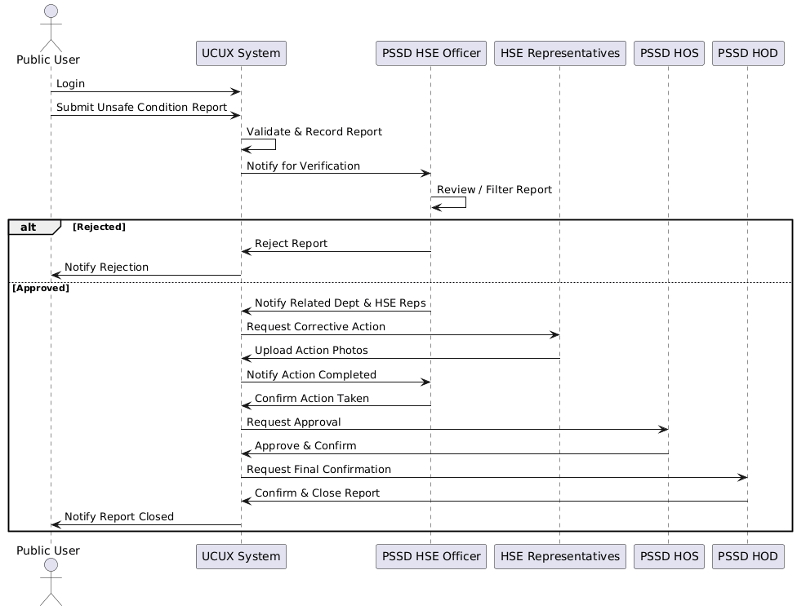
Sequence diagram for unsafe conditions
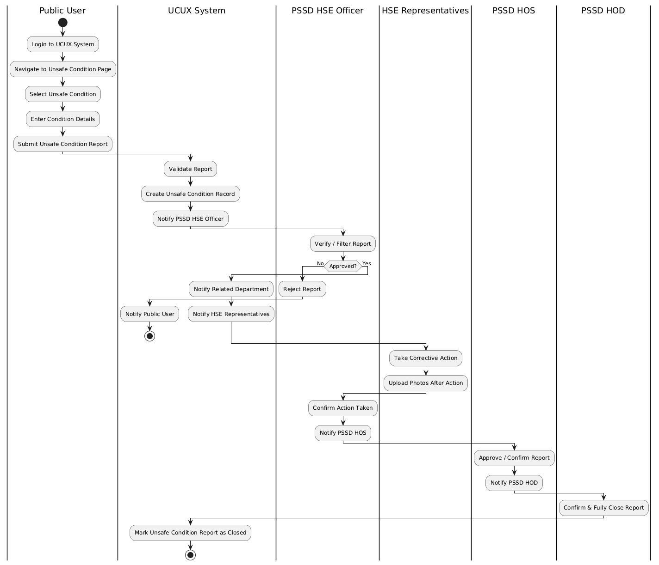
Activity diagram for unsafe conditions

Use Case 09: Unsafe Actions
Primary Actor: Public User
Goal: To report and manage unsafe actions within the Johor Port Berhad Unsafe Conditions and Unsafe Acts System (UCUX).
Description: The Public User reports and manages unsafe actions within the UCUX system, ensuring that the system is configured to meet the needs of the organization. This includes reporting unsafe actions, managing unsafe action reports, and tracking the status of unsafe action reports.
Triggers:
- The Public User needs to report an unsafe action
- An unsafe action report needs to be updated or changed
- An unsafe action report needs to be closed or resolved
Preconditions:
- The Public User has the necessary permissions and access to report unsafe actions
- The UCUX system is operational and accessible
Postconditions:
- The unsafe action report is created as requested
- The unsafe action report is updated or changed as requested
- The unsafe action report is closed or resolved as requested
Main Flow:
- The Public User logs into the UCUX system
- The Public User navigates to the unsafe action reporting page
- The Public User selects the unsafe action to be reported
- The Public User provides the necessary information for the unsafe action report
- The Public User submits the unsafe action report
- The UCUX system reflects the created unsafe action report
Alternative Flows:
- If the Public User encounters an error while reporting an unsafe action, they may need to troubleshoot the issue or seek assistance from a higher authority.
- If an unsafe action report needs to be updated or changed, the Public User may need to ensure that the report is properly updated and that the necessary changes are made.

Use Case Name | Unsafe Actions
Primary Actor | Public User
Goal | To report and manage unsafe actions within the Johor Port Berhad Unsafe Conditions and Unsafe Acts System (UCUX).
Description | The Public User reports and manages unsafe actions within the UCUX system, ensuring that the system is configured to meet the needs of the organization. This includes reporting unsafe actions, managing unsafe action reports, and tracking the status of unsafe action reports.
Triggers | - The Public User needs to report an unsafe action  - An unsafe action report needs to be updated or changed  - An unsafe action report needs to be closed or resolved
Preconditions | - Public User must be registered with a valid Public User ID.  - System access is granted to the Public User.
Postconditions | - Notification form is either fully closed or reopened (up to 3 times).  - Once the maximum reopen limit is reached, the form is fully closed.
Main Flow | - Submit UA Form – Public User submits a form with:  - Type of UA  - Location  - Date/Time  - Remarks  - Picture (optional/required)  - Verification by PSSD HSE Officer  - Officer reviews submission.  - If rejected → process ends.  - If approved → proceed to next step.  - Follow-Up Action – PSSD HSE Officer takes necessary action and notifies/forwards to related HOS.  - Verification by PSSD HOS – Selected HOS verifies and confirms.  - Approval by HOD – HOD approves and closes the form.  - Form Closed – Notification marked as closed.  - Reopen Option – Form can be reopened up to 3 times after closure.  - Full Close – After maximum reopen limit, form is permanently closed.
Alternative Flows | - Rejection Path – If PSSD HSE Officer rejects the form, the process terminates immediately.  - Reopen Exceeded – If the form has already been reopened 3 times, the system prevents further reopening and enforces Full Close.
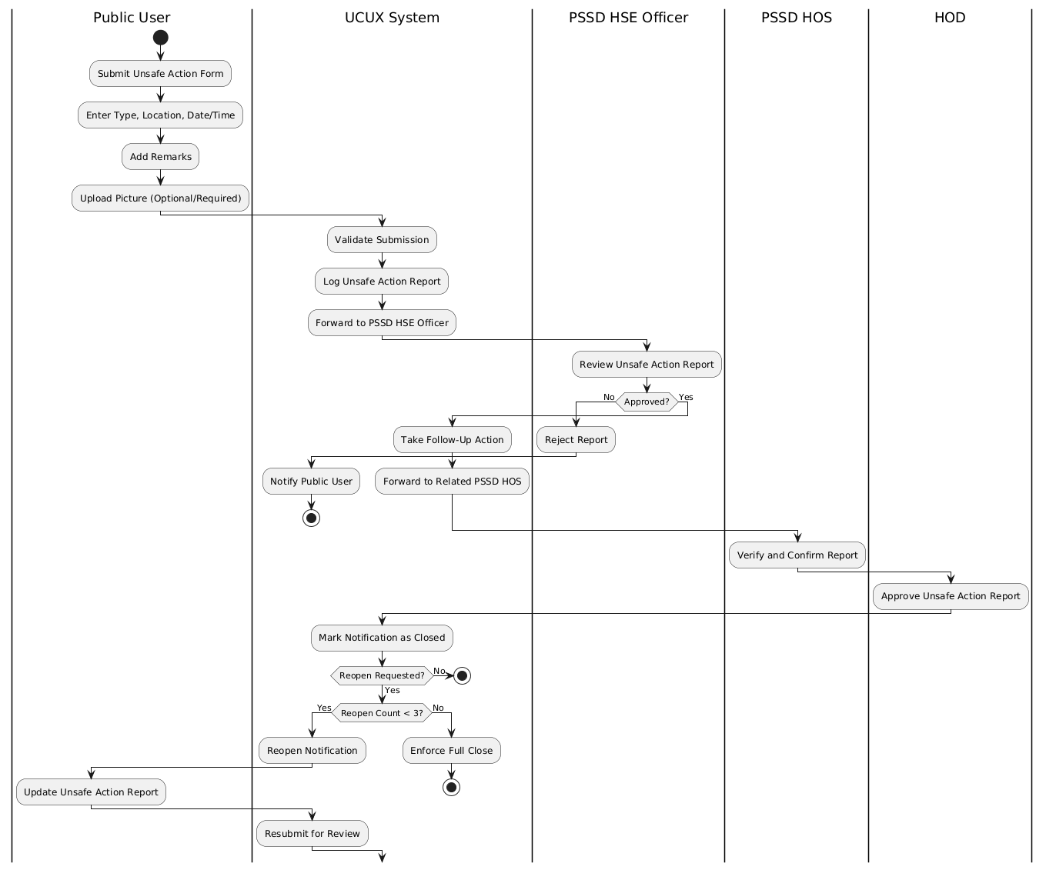
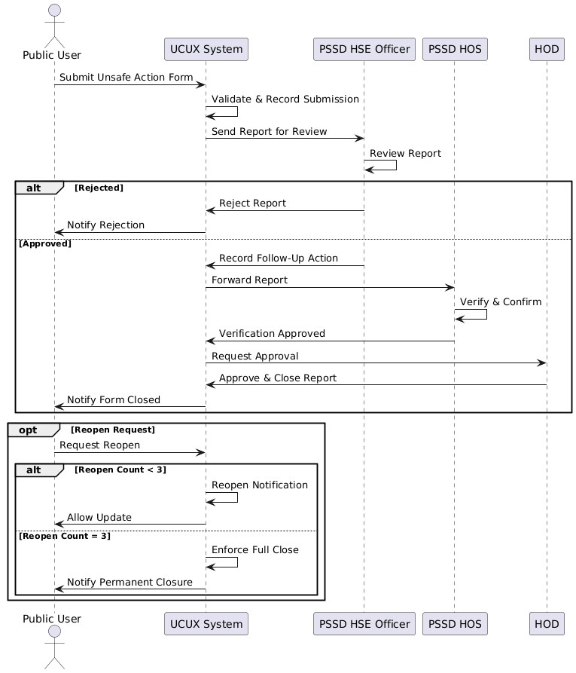

Use Case 10: Reports
Primary Actors: ICT Admin, PSSD Admin, Public User, PSSD HSE Officer, HSE Reps, PSSD HOS, PSSD HOD
Goal: To generate and manage reports within the Johor Port Berhad Unsafe Conditions and Unsafe Acts System (UCUX).
Description: The primary actors generate and manage reports within the UCUX system, ensuring that the system is configured to meet the needs of the organization. This includes generating reports, managing report templates, and tracking the status of reports.
Triggers:
- The ICT Admin needs to generate a report
- The PSSD Admin needs to generate a report
- The Public User needs to generate a report
- The PSSD HSE Officer needs to generate a report
- The HSE Reps need to generate a report
- The PSSD HOS needs to generate a report
- The PSSD HOD needs to generate a report
Preconditions:
- The primary actors have the necessary permissions and access to generate reports
- The UCUX system is operational and accessible
Postconditions:
- The report is generated as requested
- The report is updated or changed as requested
- The report is closed or resolved as requested
Main Flow:
- The primary actor logs into the UCUX system
- The primary actor navigates to the report generation page
- The primary actor selects the report template or generates a new report
- The primary actor provides the necessary information for the report
- The primary actor submits the report
- The UCUX system reflects the generated report
Alternative Flows:
- If the primary actor encounters an error while generating a report, they may need to troubleshoot the issue or seek assistance from a higher authority.
- If a report needs to be updated or changed, the primary actor may need to ensure that the report is properly updated and that the necessary changes are made.
- If a report needs to be closed or resolved, the primary actor may need to ensure that the report is properly closed or resolved and that the necessary actions are taken.

Use Case | Actors | Function
User Management | ICT Admin, PSSD Admin | The ICT Admin/PSSD Admin needs to create, update, and delete user accounts and profiles in the system. This includes adding new users, modifying existing user information, and removing inactive or terminated employees. The ICT Admin/PSSD Admin also needs to assign user roles and permissions to ensure that users have the necessary access to perform their job functions.
User Roles | ICT Admin | The ICT Admin creates and manages user roles within the UCUX system, assigning permissions and access levels to each role. This ensures that users have the necessary access to perform their tasks and responsibilities, while also maintaining the security and integrity of the system.
Settings | ICT Admin | The ICT Admin configures and manages system settings within the UCUX system, ensuring that the system operates efficiently and effectively. This includes setting up general settings, setting up company details, configuring company-wide settings, managing company users, and managing system logs.
Manage Email | ICT Admin | The PSSD Admin manages email settings and configurations within the UCUX system, ensuring that the system is configured to meet the email needs of the organization.
Manage Company | PSSD Admin | The PSSD Admin manages external company information and settings within the UCUX system.
Manage Department | PSSD Admin | The PSSD Admin manages department information and settings within the UCUX system, ensuring that the system is configured to meet the system's needs.
Manage Offense | PSSD Admin | The PSSD Admin manages offense information and settings within the UCUX system, ensuring that the system is configured to meet the system's needs.
Manage Location | PSSD Admin | The PSSD Admin manages locations and settings within the UCUX system, ensuring that the system is configured to meet the system’s needs.
Unsafe Conditions | Public User | The Public User reports unsafe conditions within the UCUX system. This includes reporting unsafe conditions, managing unsafe condition reports, and tracking the status of unsafe condition reports.
Unsafe Actions | Public User | The Public User reports unsafe actions within the UCUX system. This includes reporting unsafe actions, managing unsafe action reports, and tracking the status of unsafe action reports.
Reports | Public User, PSSD HSE Officer, HSE Reps, PSSD HOS, PSSD HOD | The primary actors generate and manage reports within the UCUX system, ensuring that the system is configured to meet the needs of the organization. This includes generating reports and tracking the status of reports.

